Customer Experience Workflow

**Solution 1: Fundraising Proposal Draft**

**April 28, 2023**

This document catalogs the Microsoft Tech for Social Impact AI Solutions Project, delivered in collaboration with threshold.world. It includes detailed description of expected customer experience for accessing, downloading, installing, deploying, and utilizing the AI Solution.

Contents

Installation and Configuration 3

Prerequisites 3

Set up an OpenAI API Key 3

Manual Solution Installation 5

Utilizing the AI Solution 12

Drafting a Fundraising proposal 12

# Installation and Configuration

## Prerequisites

It's important to review the following prerequisites before you deploy or install the solution.

* Dynamics 365 Sales Enterprise must be installed
* Microsoft Cloud for Nonprofit – Fundraising and Engagement. (see [Deploy or upgrade Fundraising and Engagement](https://learn.microsoft.com/en-us/dynamics365/industry/nonprofit/fundraising-engagement-deploy-installer))
* You must be a Microsoft Power Platform admin, Dynamics 365 admin, or a tenant admin to deploy solutions

## Set up an OpenAI API Key

Before getting an API key, you need to go to [OpenAI’s official platform website](https://platform.openai.com/). If you haven’t already, create an account following the simple steps on the website. Once you have created an account or have logged in with an existing account, you’ll see your name and your profile icon at the top-right corner of OpenAI’s platform homepage.

To get an API key,

1. Log in to your OpenAI account.
2. Click on your name in the upper right corner and select **View API keys** from the drop-down menu**.**

1. To get a new secret key, click the **Create new secret key** button near the center of the page. 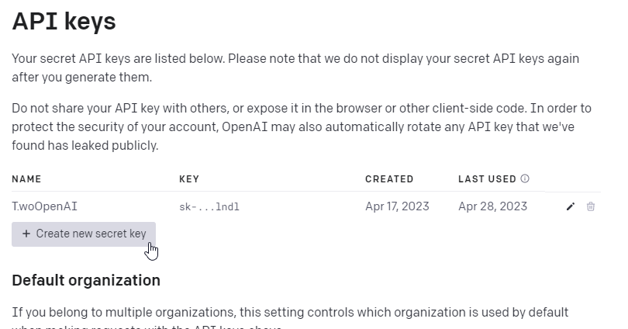
2. On the create new secret key dialog, enter a name for your API key and click **Create secret key**

1. A new secret key will be generated. Make sure to save the secret key somewhere safe as soon as possible. Once the dialog closes, you won’t be able to view the secret key again.

## Manual Solution Installation

1. Before installing the solution, make sure you have the solution file in your machine. (Filename: **TSI_OpenAI_FundraisingProposalDraft_1_0_0_0.zip**)
2. Go to the [Maker Portal](https://make.powerapps.com/)
3. On the top right, select the environment where you want to install the solution.

1. On the left navigation pane, click **Solutions**

1. Click **Import solution**

1. Browse to the location of the solution file downloaded at step 1 and click **Next**

1. On the confirmation window click **Next**

1. The import process will ask you to reestablish a connection. A connection is needed for the Power Automate Flow that is part of the solution. This connection provides access to the org-based database on Microsoft Dataverse in current environment. If a connection already exists, you can select it from the dropdown and you can jump to step 12. In case there are no connections, Click the dropdown next to the connection reference and click **New Connection.**

1. A new window will open to create the connection. On the dialog, click **Create**

1. Pick an account or log in with an account that has access to the current Dataverse Environment

1. After creating the connection, go back to the previous window and click **Refresh** on the dialog shown. That will refresh the connections dropdown.

1. Select the newly created connection from the dropdown next to the connection reference and click **Next.**

1. Paste your API key from OpenAI on the Environment Variable **OpenAI API Key** and click **Import.** (to get an OpenAI API key see section ***Set up an OpenAI API Key***)

1. Wait until the import process completes.

# Utilizing the AI Solution

## Drafting a Fundraising proposal

Fundraisers can reach more prospective donors by quickly drafting personalized fundraising proposals with OpenAI in the Microsoft Cloud for Nonprofit.

With the click of a button, fundraisers can generate a draft fundraising proposal email that can be edited and sent to prospective donors. The draft proposal is generated by Open AI based on the context of an opportunity, a donor’s profile, interests, and funding priorities in the Microsoft Cloud for Nonprofit.

The following guidelines will show how to use the predeveloped solution:

1. Go to your organization’s Dynamics 365 CRM portal (e.g.

<https://organizationid.crm.dynamics.com>).

1. From the list of apps, select the **OpenAI Solutions** model-driven app

1. From the navigation pane, select **Opportunities**, and open an existing opportunity record

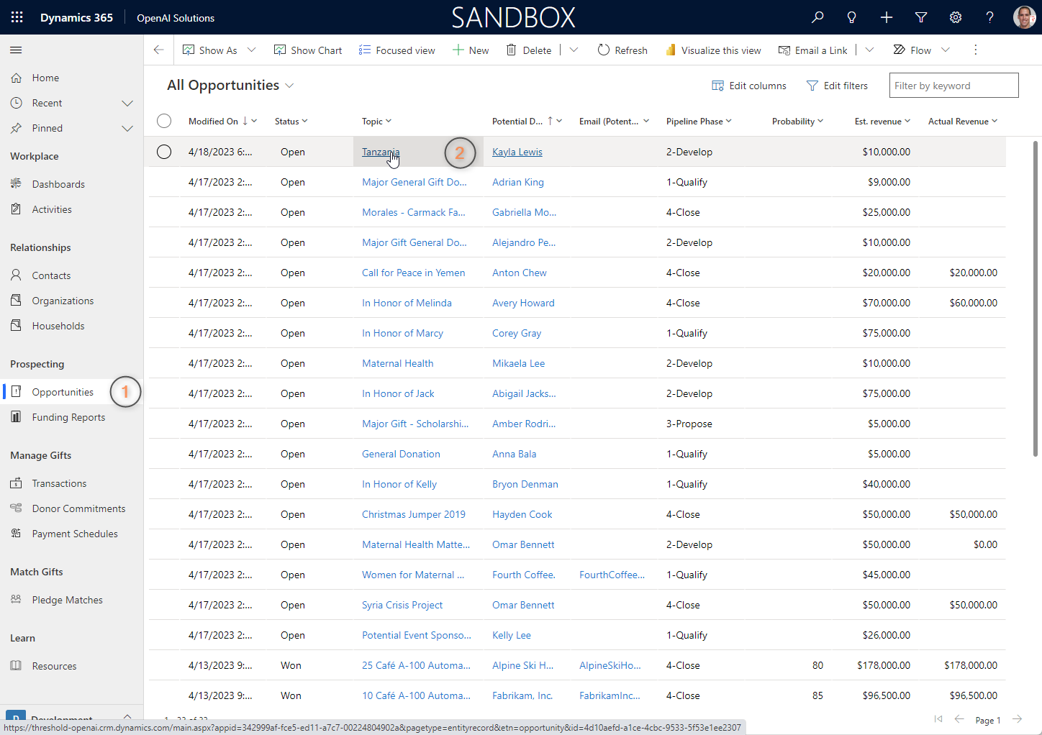

1. To draft a Fundraising Proposal Letter, click on the Draft Proposal button inside the opportunity form.

1. A side panel dialog shows, which allows to add more guidance or context before sending the data to OpenAI. Some examples of Additional Guidance for OpenAI include:
   1. “The letter should be written as if It was written by John Smith (Fundraising Director of ABC Organization)”
   2. “The proposal must be written in Spanish”

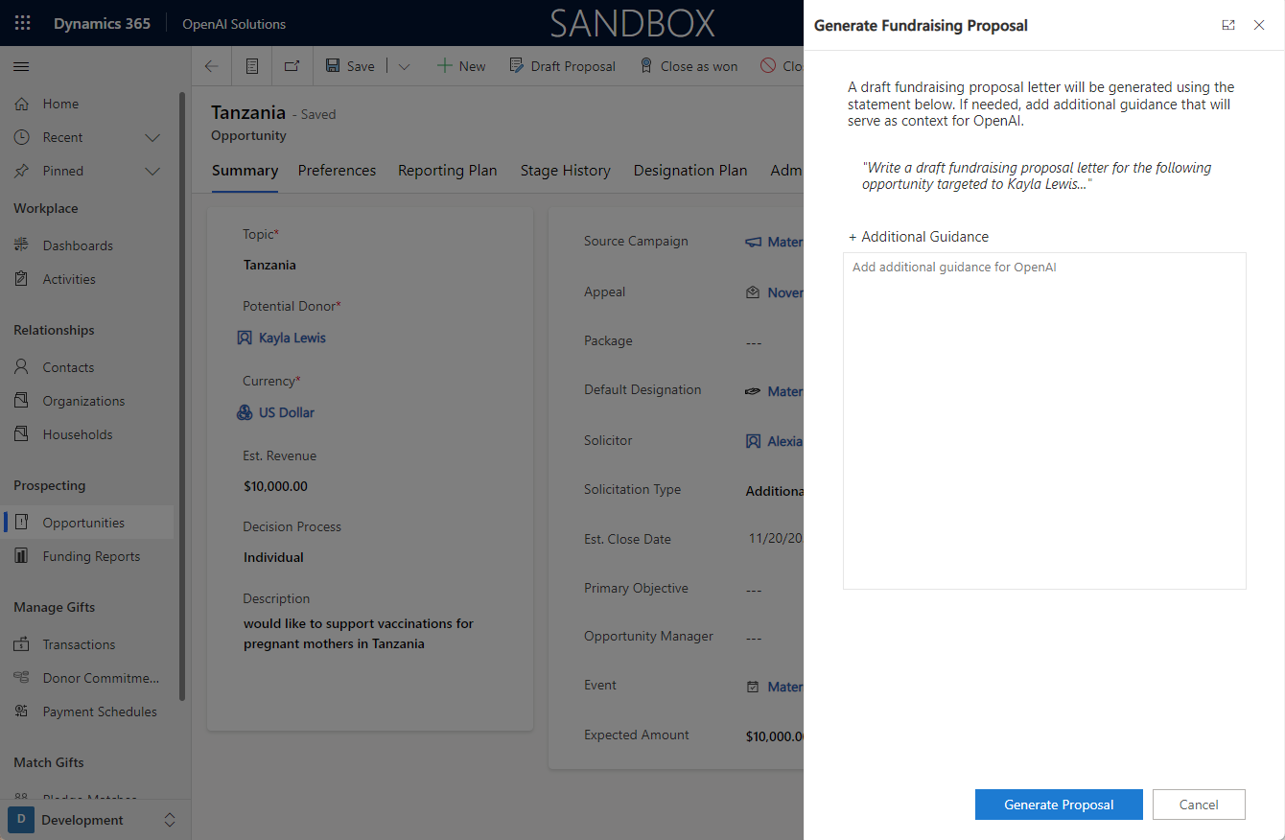

1. Once the additional context is added (is optional), click **Generate Proposal.** After the generation of the proposal completes, the dialog will show a confirmation.

1. The **Open Email** button allows opening the newly created email record right from the dialog. If the user dismisses the dialog, instead of clicking the button, the timeline in the opportunity refreshes to show the email on top of the list.

